Part-A
Profile & vision of Software –
Kameet Tax & Investment Consultancy (Taxation Division)
Kameet Taxation provide Service to its client in area of Mainly in Accounting, Income Tax Return Filling, GST Return Filling, Outsourcing of Income Tax Audit work and other major/minor task as per client requirement.
            - Client Structure – it is very important to understand client structure for this software. Let’s Understand its with Example.
- What is (Client) Group

For example, if Bachchan Family is my client than “Bachchan Family” may be Group name for me or some time I put same name of any family member as my group name like “Amitabh Bachchan”.

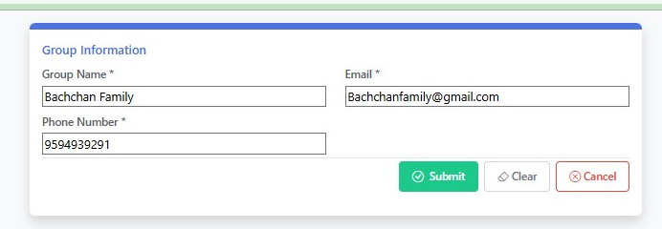

- What is Client
Now In “Bachchan Family” Group My Clients are 1. Amitabh Bachchan 2. Jaya Bachchan 3. Abhishek Bachchan 4. Ashwarya Ray Bachchan 5. AB Corp. as individual Capacity and may they be proprietor of own firm (Client Name) like “KBC Entertainment” Proprietor By (Legal Name) “Amitabh Bachchan”. Now all details provide by me by “Mr. Abhishek Bachchan”
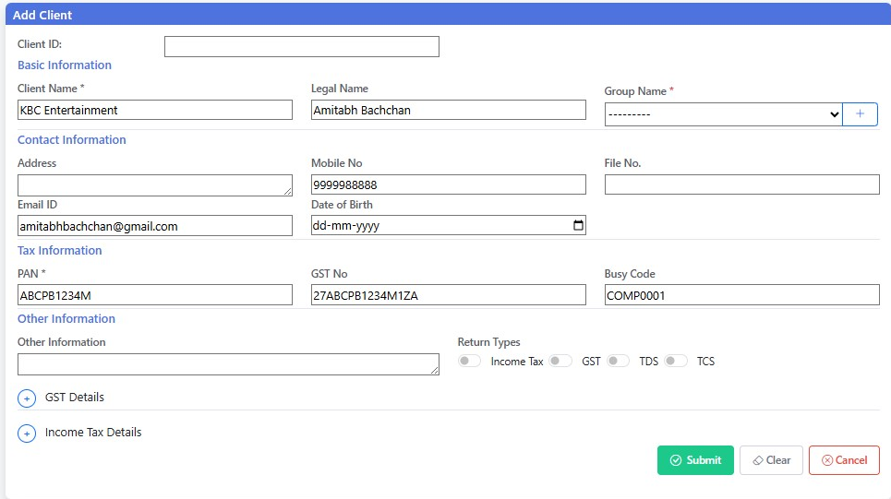

So, Client Data may be received from “Group Client Id” or “Any of group member id’ or “Email id stored in Bank account master”. For example, in above case Mrs. Ashwarya Rai Bachchan has one savings account which is her personal account as Tradition (By Support her mother Mrs. Brindya Rai) with email id Bindyaashwariya@gmail.com . now, this statement uniquely received from this email and may Aishwarya rai Bachchan use same email id with joint bank account of Abhishek Bachchan. So, some time surprise Abhishek Bachchan account detail received from Bindyaashwariya@gmail.com

            - Document Record
- Client (Bank) Account
That “KBC Entertainment” Current Account in ICICI BANK Woth account no. 0366111101942. He has multiple account like Saving Account/Current account/Overdraft account. With His Client name or Legal Name as earlier Discussion.
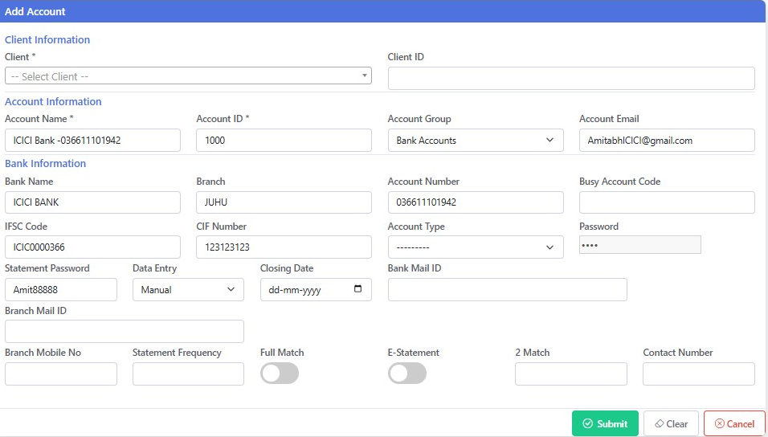

Now, Same way their family Member have their Bank account with their Client name Account and/or Legal Name. and periodically receiving statement by Auto forwarded Email(acstkameet@gmail.com), Manual Email(itpamitmehta@gmail.com) or on WhatsApp (By as of now we download in computer and add manually in our Software).
- Other Document
As Accounting & Tax Consult firm We need other records like share broker report, property transaction report, Bank Loan Statement, Vehicle purchase Invoices and much more. Some of these transactions are once in while where other need every year like. Vehicle purchase is unique event not every year. But, share broker reports need every year. We, classified same in our system. These documents receive by us on any above email or WhatsApp. So, we try to design mail list to find such mail and store same in our document list record System.

Part - B
Requirement of Update in Kameet Software
Client/Group Master
- Delete/Suspend Client Group option: -
    - If Client/Group Has zero Transaction Can Delete from Master
    - If Client/Group Has Any Transaction Can Suspend from Effective date as we mention, suggestion with last transaction date found.

- Group, Client, Use and Account Modification allow from List Report.
Bank Report – Major Part of Software as of now
- Bank Report – Some mail attached multiple time in Report.

- After any Action Screen filter and report change. Need to stable on screen before action taken. (Specially experience after Data Entry Status Change by clicking two time on entry) (some time this change display after 5-10 second)

- Bank Report Bugs – When move tab and reveres come to original screen report generate full detail instead of group /Client Specified.

- All Mail received are store in Mail Log file. There is our email ID acstkameet@gmail.com who received auto-forwarded mail from “Client Email ID”. Our system design to identify If Mail Received for Bank Statement in Mail Log under email ID acstkameet@gmail.com and auto-forwarded by Client Email ID. is for which bank account ID and for which period, by using Email ID Registered in Group ID, Client ID or Bank Account ID.
Also, this Match in work by using Bank Name, CIF Number, Bank Account Number (also look some Digit) and Match option Provided in Bank Account ID. If not found we “Need to update in Mail Log. Where this Mail Received”. So, this option Need to Create.

- Auto Mail attachment system even If PDF is there some time jpg attached in record (as jpg only allowed when data attach manually due to screen shot of statement but if bank provide same it must be pdf/CSV/XLS/XLSX/RTF/DOC or any other data source format)

- Using Account Modification Option After Save exit option not found (Nee to check every In out option in Bank Report) (Find below tab in Bank Report)

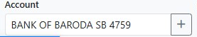

Mail Log – Major Part of Software as of now

- Mail Log. Filter must be use when we enter in Mail Log this help us to work with limited data instead of All data all time.

- Mail Log - Need to check All mail received by Fetching from Mail are available or not in log. Both Aacstkameet@gmail.com and itpamitmehta@yahoo.co.in

- Mail Log – Tagging Requirement Email is not useful or Need to Avoid. (some mail from client side is not useful data and need to avoid)

- Mail Log – Document Specify – this tab need to start, it’s not in working or not create properly.
Also Need if client Provide Bank Statement its need to save from document Specify (“As this task is not auto recuring saving but client mailed randomly)

- Transaction data Entry Tab Was generated for Sale/ Purchase data Received record it will be operate after other bugs issue resolve.

